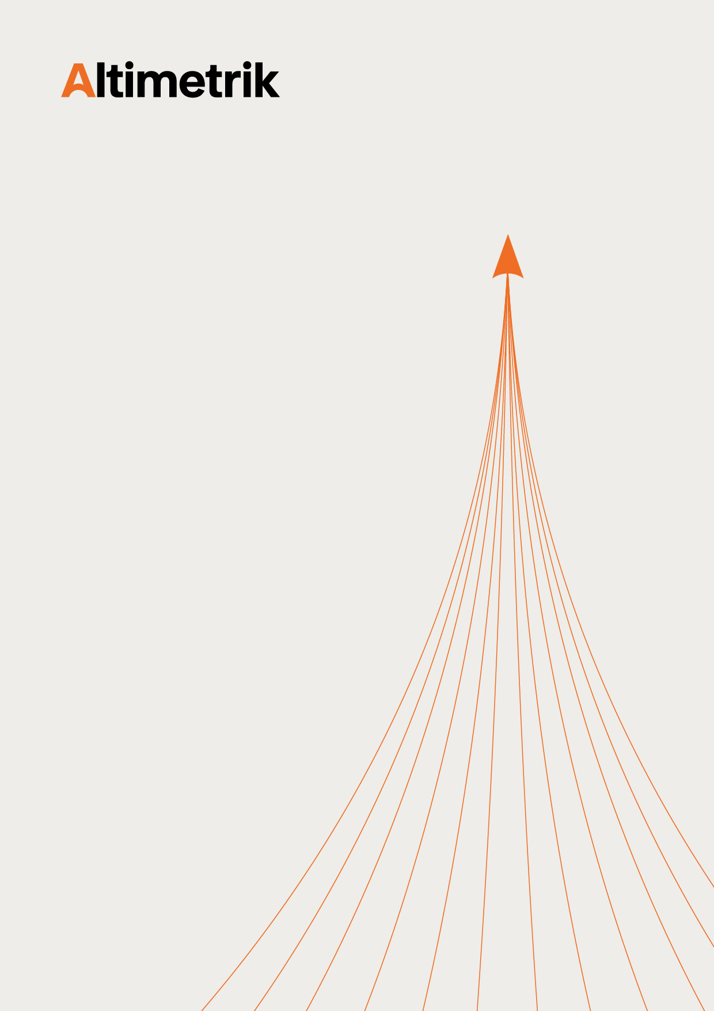

Clear Desk Clear Screen Policy v2.0
Document Summary:

Policy ID | ESGC-IS-34
Revision Number | 2.0
Effective Date | 1-July-2026
Owner | ESGC
Approved By | Raghavendra K (CISO)
Document Status | Approved
Document Label | Internal Information

This document contains internal and proprietary information of Altimetrik and is intended for authorized internal use only. The information contained herein shall not be disclosed, reproduced, distributed, or shared with any third party without prior written consent from Altimetrik. Unauthorized access, use, modification, disclosure, or distribution of this document is strictly prohibited and may result in disciplinary and/or legal action. Altimetrik reserves the right to modify or update this document as required. The version published on the official Altimetrik intranet portal shall be considered the latest approved version for reference.

Revision History:

Date of Revision | Version | Description | Author | Reviewed by | Approved by | Approved Date
2-June-2026 | 2.0 | Policy harmonized and revised to establish a unified standard across Altimetrik group companies | Sunanda K  (Senior Engineer, ESGC) | Shivaramakrishna Seetharaman (Head-IT infra)  Deepak Athisivan Thiraviam  (Senior Manager, ESGC) | Raghavendra K (CISO) | 26-June-2026

TABLE OF CONTENTS

1. INTRODUCTION 4
2. ISO/IEC 27001 CONTROL REFERENCE 4
3. SCOPE 4
4. ACRONYMS USED 4
5. POLICY 4
5.1 Clear Desk and Clear Screen 4
6. KEY PERFORMANCE INDICATOR 5
7. DOCUMENTS REFERENCES 5

Introduction

The purpose of this policy is to implement clear desk and clear screen controls to reduce the risk of security breaches, unauthorized access or damage to papers, media, and information processing facilities across all the organization.

ISO/IEC 27001 control reference

ISO/IEC 27001:2022 Information Security, Cybersecurity and Privacy Protection – Information Security Management Systems – Requirements
- A.7.7 – Clear Desk and Clear Screen Policy

Scope
- This policy applies to Altimetrik Group Companies (hereafter referred to as the organization).
- Information and information processing systems (including but is not limited to, documentation, personnel, hardware, software, physical and logical controls, network communication systems and data that are in possession of or using facilities) owned by organizations across all global locations and facilities.
- All employees, contractors and service providers working for Organization and using its information and information systems.
In case of any conflict, applicable laws & regulations shall always supersede this policy.

Acronyms used

Acronym | Expanded Form
CISO | Chief Information Security Officer
ESGC | Enterprise Security Governance and Compliance is an Enterprise Information Security Department
IT Infra | Information Technology and Infrastructure Operations

Policy

Clear Desk and Clear Screen
- Users must keep all sensitive, confidential classified documents and any removable storage media in a locked cabinet in their absence and when not in use.
- Employees shall not leave devices logged on (such as desktop computers, laptops, mobile phones, tablets, media, etc.) when unattended and should be protected by PIN, passwords, or other controls when not in use, where feasible.
- All information systems (desktops and laptops) shall be enforced with password protected screensavers within 300 seconds (5 minutes) of inactivity.
- Any given point of time password shall not be written or displayed on any medium.
- Incoming and outgoing mail/ couriers collection/ dispatch counters shall be appropriately protected against unauthorized access.
- All active application sessions shall be terminated (manually by user) upon completion of work.
- Controlled information (Sensitive and Confidential documents) shall not be reproduced (printed, photocopied, etc.) without business need. At the end of each session all sensitive, confidential information shall be removed from the workplace and stored in a locked area.
- Photocopiers and other reproduction technology (e.g., scanners, digital cameras) shall be protected from unauthorized use. Organization ensures access control network printers/ scanner are installed to restrict unauthorized photocopying and printing.
- Employees using photocopiers and printers shall be responsible for ensuring that no documents, whether originals or copies, are left unattended at these devices. Sensitive or confidential information shall be collected immediately after printing.
- All unwanted sensitive, confidential, and internal classified documents shall be shredded after use, following a general principle “shred if not required”. Confidential information/printouts shall not be thrown on trash.
- Sensitive and confidential classified paper documents should not be left unattended in meeting rooms or common areas such as pantry, reception, etc. Any information written on whiteboards or flip charts must be wiped off at the end of the discussion or meetings.
- Copies of documents shall be made only by authorized persons on a need-to-know basis.
- Reproduced documents shall bear the same security markings or classification as the originals.
- System or application notification shall be configured to hide the content of notification.
- Users shall ensure virtual backgrounds and window previews do not display Confidential or Sensitive information. Shared room displays must be cleared before and after meetings.
- Users handling sensitive or confidential information must ensure they do not share their screens during calls or meetings with external parties.

Key performance indicator

Srl. | KPI Definition | Frequency
1. | Number of data breaches caused by physical access to unattended workstations or data access to unlocked computers. | Half Yearly
2. | Number of critical or high severity security incidents reported due to inadequate clear desk or clear screen controls. | Half Yearly

